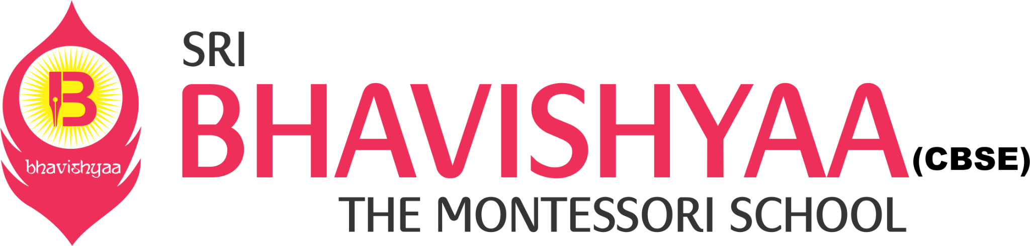

**MONTHLY NEWSLETTER FOR HIGH SCHOOL - JULY**

**THEME: NOBEL PRIZE**

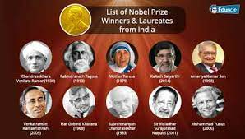

|  |  |  |  |  |
| --- | --- | --- | --- | --- |
| **DATE** | **EVENT** | **RESOURCES** | **PARTICIPANTS** | **DESCRIPTION** |
| 19-07-21 | Noble Prize Week (Field: Peace) | as per the requirement | The class will be divided into five groups. Each group will be assigned one field | Students should research on the assigned field, find out the facts and prepare a ppt on a Noble Peace prize winner. The slide show should consist of relevant pictures and description. Each student of the group will give the presentation to the whole class. |
| 20-07-21 | Noble Prize Week (Field: Chemistry) | as per the requirement |
| 22-07-21 | Noble Prize Week (Field: Physics) | as per the requirement |
| 23-07-21 | Noble Prize week ( Field: Medicine) | Chart, color pens, pencils, pictures of noble prize winners in medicine |
| 24-07-21 | Noble Prize week ( Field: Literature) | as per the requirement |
| 27-07-21 | Around the World Country with letter "D | as per the requirement | whole class |  |
| 30-07-21 | Happy Friendship’s Day My best Friend! | as per the requirement | whole class | Students should prepare a ppt on My best Friend! Name, your best friend qualities, the most memorable moment. |

|  |  |  |  |  |  |
| --- | --- | --- | --- | --- | --- |
|  |  |  | |  | | --- | |  | | | | | |  |
|  |  |  |  |  |