

**MONTHLY NEWSLETTER FOR PRIMARY - JULY**

**THEME: ADVOCATE**

** **

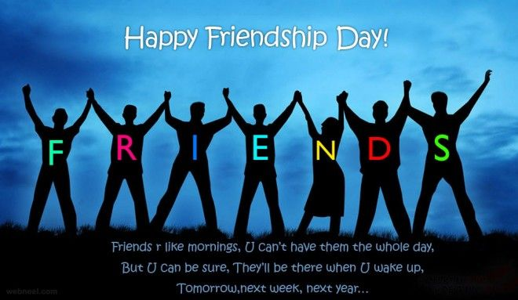 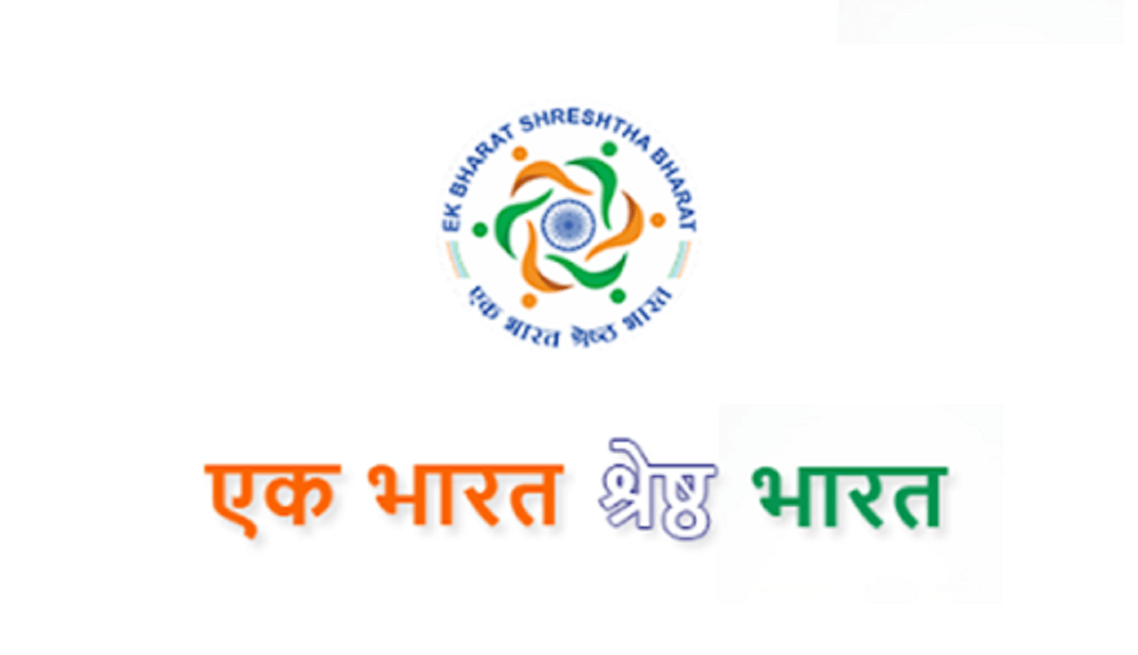

|  |  |  |  |  |
| --- | --- | --- | --- | --- |
| **DATE** | **EVENT** | **RESOURCES** | **PARTICIPANTS** | **DESCRIPTION** |
| 12-7-21 | International Justice Day |  |  | Special Assembly will be conducted on International justice day and the Advocate week orientation will be given. |
| 13-7-21 | If I am a Lawyer | Chart, color pens/pencils/crayons, information about characteristics of a wise lawyer, students own photo. | whole class | Students will research on the profession - Lawyer and write an essay. Students should paste their picture on the chart and write an essay on " If I am a lawyer " in minimum 50 words. |
| 14-7-21 | Poster making Do's and Don'ts | Chart, color pens/pencils/crayons | whole class | Prepare a poster showing Do's and Don'ts of Lawyer, the ethics and code of conduct to be followed by the profession. |
| 15-7-21 | Talk on Lawyer | chart, color pens/pencils, Revision work prior to the activity | Group of students | Five students from each class will be selected on the basis of name wheel. These students will be informed a week before, they have to explore and prepare themselves on LAWYER and give a talk for 5 mts. |
| 16-7-21 | Guest Lecture | as per the requirement | whole class | Students will get an opportunity to meet a Lawer and attend the seminar conducted by the Lawyer. |
| 20-7-21 | Ek Bharat Shrest Bharath state/UT with letter 'D' | Chart, picture of map, colors, and other writing material | whole class | Students will choose a state or UT which starts with letter D. They will research about the state/UT. In the research they will find out about the geaographical features, History, monuments, Poltical life and famous people of the state. Students will draw the map of the state and present all the facts about the place in the chart. In the class each child will get 5 mts time to share their presentation. |
| 30-7-21 | Happy Friend ship Day | chart, colors and other writing materials | whole class | Students should prepare greeting cards and wrist bands for their friends. They should show their work and talk about their friend. |

|  |  |  |  |  |  |
| --- | --- | --- | --- | --- | --- |
|  |  |  | |  | | --- | |  | | | | | |  |
|  |  |  |  |  |