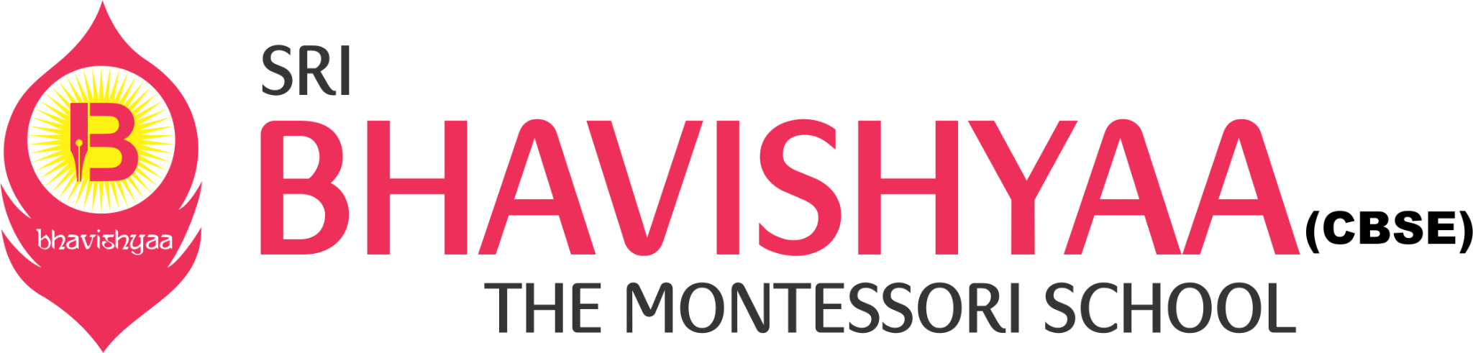

**BMS/CBSE/DVK/02**

Dear Parent,

Greetings from Bhavishyaa!

This is to inform you that PERIODIC TEST 2 will begin from 26th July 2021. Time table and syllabus will be shared on 15th July 2021.

Examination Procedure:

1. PRIMARY SCHOOL:

Each exam will be conducted in three parts as follow:

Section A - Descriptive: Section A will be a descriptive exam. The exam will be conducted for 10 marks and the duration of the exam will be 45 minutes. Teachers will share the question paper through Google classroom and students will write the exam in the presence of the teacher. The answer scripts need to scanned and submitted in Google classroom by 4.30pm

Section B - Objective: Section B will be an objective paper. The objective paper format will be in Google form. The exam will be conducted for 10 marks and the duration of the exam will be 30 minutes. Students need to answer the questions in Google form.

Section C - VIVA: Section C will be a VIVA exam. The exam will be conducted for 5 marks and the duration of the exam will be 10 minutes. The subject wise time slots for children will be shared with the parents, well in advance. Teacher and student will login into their respective Google class links and attend the viva.

1. HIGH SCHOOL:

Each exam will be conducted in three parts as follow:

Section A - Descriptive: Section A will be a descriptive exam. The exam will be conducted for 10 marks and the duration of the exam will be 45 minutes. Teachers will share the question paper through Google classroom and students will write the exam in the presence of the teacher. The answer scripts need to scanned and submitted in google classroom by 4.30pm

Section B - Objective: Section B will be an objective paper. The objective paper format will be in google form. The exam will be conducted for 10 marks and the duration of the exam will be 30 mts. Students need to answer the questions in google form.

Section C -Case Study : Section C will be case study analysis. The exam will be conducted for 5 marks and the duration of the exam will be 60 mts. Students will read the case and analyse and write their analysis in a paper. The answer scripts need to be scanned and submitted in google classroom.

ATTENDANCE: 100% Attendance is mandatory for the exams.

NOTE: 1.No re-examination will be conducted

2.Descriptive paper should be submitted by 4:30 pm.

3.During VIVA round ,only the child who is asked should unmute his device and

speak.