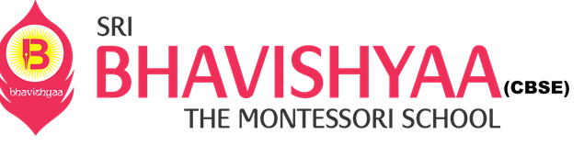

**NEWS CALENDAR – HIGH SCHOOL**

|  |  |  |  |  |  |  |  |  |
| --- | --- | --- | --- | --- | --- | --- | --- | --- |
| **AUGUST** | | |  | **School Calendar 2021-2022** |  | **AUGUST** | | |
| **MON** | **TUE** | **WED** |  | **Ek Bharat Shreshta Bharat Week * 9th Aug -** Acheivements of State/UT " A -F" **\* 10th Aug** - Achievements of State/UT " G-L" **\* 11th Aug** - Achievements of State/UT " M-Q" **\* 12th Aug** - Achievements of State/UT " R-U" **\*13th Aug** - Achievements of State/UT " V- Z" **\* 14th Aug** - India Collage Making   **23rd - 26th Aug - Periodic Test - II**  **28th Aug - Indian Heritage Show  Values of Bhagavad-Gita** |  | **THUR** | **FRI** | **SAT** |
| **9** | **10** | **11** |  |  | **12** | **13** | **14** |
| **16** | **17** | **18** |  |  | **19** | **20** | **21** |
| **23** | **24** | **25** |  |  | **26** | **27** | **28** |
| **29** | **30** | **31** |  |  |  |  |  |

**Reach us @** [**www.bhavishyaaschools.com**](http://www.bhavishyaaschools.com)

