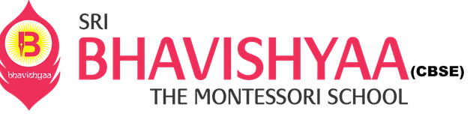

**NEWS CALENDAR – PRIMARY**

|  |  |  |  |  |  |  |  |  |
| --- | --- | --- | --- | --- | --- | --- | --- | --- |
| **AUGUST** | | |  | **School Calendar 2021-2022** |  | **AUGUST** | | |
| **MON** | **TUE** | **WED** |  | **Ek Bharat Shreshta Bharat Week * 9th Aug -** Drawing Competition  **\* 10th Aug** - Singing Competition  **\* 11th Aug** - DIY Competition **\* 12th Aug** - Dance Competition  **\*13th Aug** - Drama **\*14th Aug** - Guest Lecture Proud Indian   **23rd - 26th Aug - Periodic Test - II**  **31st Aug -** Ek Bharat Shreshtha Bharat  State/UT with letter "G" |  | **THUR** | **FRI** | **SAT** |
| **9** | **10** | **11** |  |  | **12** | **13** | **14** |
| **16** | **17** | **18** |  |  | **19** | **20** | **21** |
| **23** | **24** | **25** |  |  | **26** | **27** | **28** |
| **29** | **30** | **31** |  |  |  |  |  |

**Reach us @** [**www.bhavishyaaschools.com**](http://www.bhavishyaaschools.com)

